**Push Button**

**Push Buttons** are normally-open **tactile switches**. Push buttons allow us to power the circuit or make any particular connection only when we press the button. Simply, it makes the circuit connected when pressed and breaks when released. A push button is also used for triggering of the SCR by gate terminal. These are the most common buttons which we see in our daily life electronic equipment’s.



**Piezo Buzzer**

A **Buzzer**is a small yet efficient component to add sound features to our project/system. It is very small and compact 2-pin structure hence can be easily used on [**breadboard**](https://components101.com/misc/breadboard-connections-uses-guide)**,** Perf Board and even on PCBs which makes this a widely used component in most electronic applications.

There are two types of buzzers that are commonly available. The one shown here is a simple buzzer which when powered will make a Continuous Beeeeeeppp.... sound, the other type is called a readymade buzzer which will look bulkier than this and will produce a Beep. Beep. Beep. Sound due to the internal oscillating circuit present inside it.

This buzzer can be used by simply powering it using a DC power supply ranging from 4V to 9V. A simple 9V battery can also be used, but it is recommended to use a regulated +5V or +6V DC supply. The buzzer is normally associated with a switching circuit to turn ON or turn OFF the buzzer at required time and require interval.

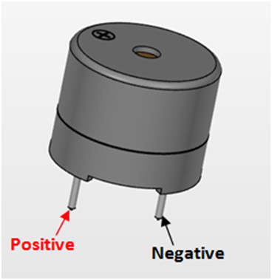

**Buzzer Features and Specifications:**

* Rated Voltage: 6V DC
* Operating Voltage: 4-8V DC
* Rated current: <30mA
* Sound Type: Continuous Beep
* Resonant Frequency: ~2300 Hz
* Small and neat sealed package
* Breadboard and Perf board friendly